**Kickstarting with Excel**

Toni Hewin

MSU- Data Analytics Bootcamp

**Overview**

The purpose of this report is to analyze how plays and theater prospered according to their launch dates and funding goals.

**Analysis and Challenges**

**Outcomes based on Launch Date**

For the first analysis “Outcomes based on Launch Date”, I took the Kickstarter table in Excel; which shows a range of different categories for plays, theater and musicals in multiple Countries. I created a column to formulate the year by extracting information from the date created conversion column on the table. From there, the table was filtered based on successful, failed, and canceled theater based on the launch date. Next, a pivot table was done, and a line graph was created to show the relationship between outcomes and launch month.

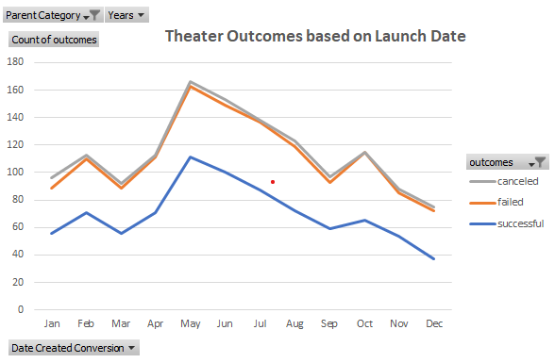

**Outcomes Based on Goals**

For the second analysis “Outcomes Based on Goals”, the same Kickstarter table was used. First, to calculate the goals range for successful, failed, and cancelled plays the “Countifs() function in Excel was used. Next, the sum formula in excel was used to get the total percentage of the outcome. Lastly, a line chart was created to show the difference between the goal amount ranges, and percentages of the successful, failed, and canceled plays.

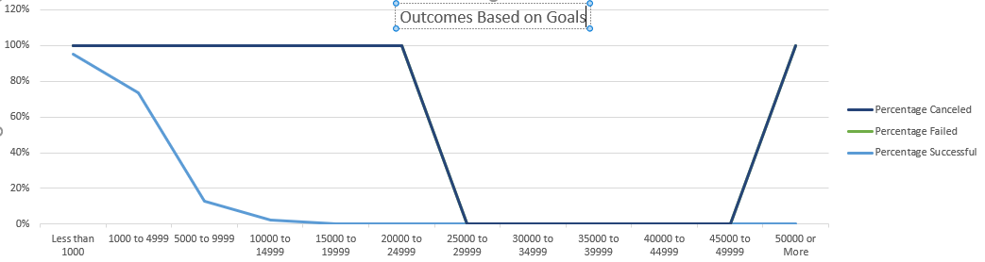

**Challenges and Difficulties Encountered**

The Challenges, and difficulties encountered were using the “Countifs() function, it took a few hours playing with the formula to get it to line up properly. I kept getting an error message, showing the cells were being added. I used Google, YouTube, and slack resources provided to find the solution.

**Results**

In the Outcomes based on Launch Date analysis, I found that there are more successful theater campaigns, than cancelled and failed. In addition, theater is more successful during the warmer months of May-August.

In the Outcomes based on Goals I found that plays with a goal range of under $5000 has a better success rate of 73 percent or higher.

The limitations found in this dataset were theater based on launch date, and plays based on range goals. Other possible tables we could’ve considered were the States, or adding other campaigns such as musicals.

**Conclusion**

In conclusion, it’s best to launch theater campaigns during the Summer due to the success rate, and a more reasonable goal range under $5000 provides the best success rate for plays than the goal range of $5000 and up.

**Resources**

[**www.youtube.com**](http://www.youtube.com)

[**www.slack.com**](http://www.slack.com)

[**www.google.com**](http://www.google.com)